Sales and Inventory Database Management System

**Prepared for:** Pharmacy

**Prepared by:** Nicole John Mortel

**IToolbox ™**

John Paul Francisco

**Release Date:** November 29, 2020

**Version number**: 0001

# EXECUTIVE SUMMARY

## Overview

This user acceptance document is to accept the functionality of the requirements for Pharmacy Inventory with Database Management System which includes the following feature:

* Login of user
* Viewing of products and inventory
* Adding of products inventory in database
* Update of products inventory in database
* Manage Employee Transaction who update the database
* Generate report of the inventory

## Objective

To be able to create database management system for Pharmacy Inventory.

## Goals

To have an inventory of pharmacy’s products and services.

## Solution

Based on the understanding of Pharmacy requirements, IToolbox developed a database management system for Pharmacy that will have an inventory of their products in stand-alone system.

## Project Outline

**IToolbox ™**

## User Interface Design

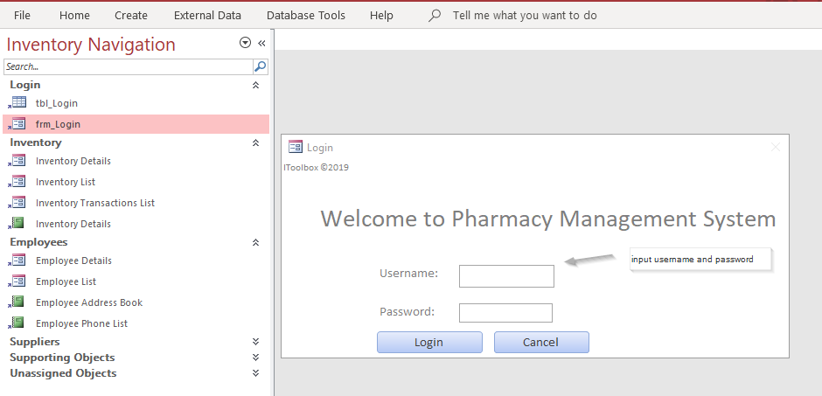

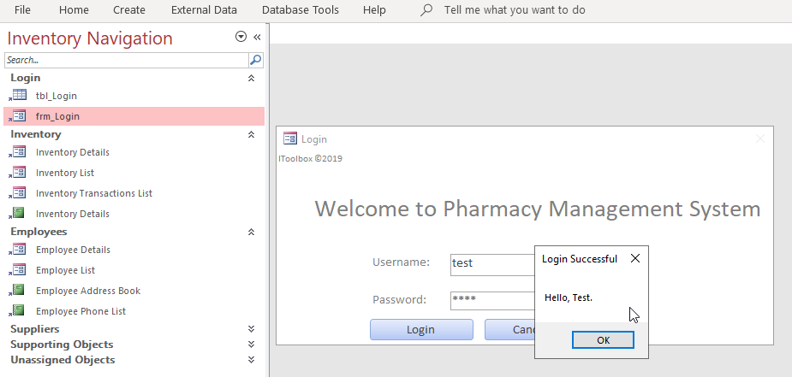

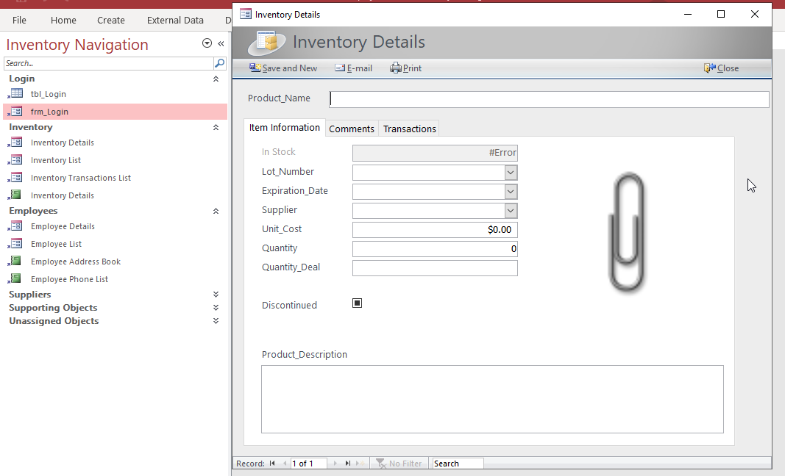

## Project Cost

**IToolbox ™**

This project cost 8,000 pesos which includes database management features of pharmacy inventory.

## Key Stakeholders

|  |  |
| --- | --- |
| Client | Aileen Paradero |
| System QA | John Paul Francisco |
| Systen Developer | Nicole John Mortel |

## Evaluation / Feedback

## Approval Signatures

|  |  |  |  |  |
| --- | --- | --- | --- | --- |
|  |  |  |  |  |
| Aileen Paradero  Project Client |  | John Paul Francisco  System QA |  | Nicole John A. Mortel  System Developer |